Tab 1

Subjective Questions

Q1. Customer Behavior Analysis: What patterns can be observed in the spending habits of long-term customers compared to new customers, and what might these patterns suggest about customer loyalty?

Sol:
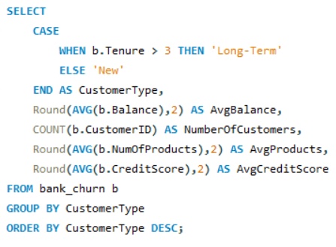

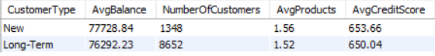
Insights:
- Comparable Average Balances Across Tenure Segments
Both new and long-term customers maintain similar average balances, with new customers showing a slight edge. This indicates that new customers tend to deposit or transact higher amounts early in their lifecycle, signalling stronger initial engagement.
- Product Holding Behaviour
Long-term customers exhibit a marginally lower average number of products (1.52) compared to new customers (1.56). This suggests that long-term customers typically consolidate around a core set of products, whereas new customers are slightly more exploratory in their early relationship with the bank.
- Credit Score Dynamics
New customers show a marginally higher average credit score than long-term customers. This may reflect:
  - A more credit-conscious emerging customer base
  - Targeted acquisition strategies that favour high-credit-score individuals
  - Improved onboarding screening mechanisms
- Customer Base Composition
Despite slightly lower product usage and credit scores, long-term customers constitute the majority of the customer base. This demonstrates solid retention strength but simultaneously highlights untapped potential for cross-selling and deeper product penetration.
Recommendations :

Enhance Long-Term Customer Engagement
Since new customers adopt slightly more products, prioritise retention-driven cross-sell and upsell strategies targeted at long-term customers. This will help deepen wallet share and improve overall product utilisation.

Deploy Customer Loyalty & Rewards Programs
Implement tenure-based or engagement-tiered loyalty programs that reward long-term customers for maintaining balances and encourage them to onboard additional products.

Strengthen High–Credit-Score Acquisition Pipelines
With new customers showcasing higher credit scores, refine marketing and acquisition campaigns to attract more high-quality, credit-strong profiles and incentivise them to build longer-term relationships.

Q2. Product Affinity Study: Which bank products or services are most commonly used together, and how might this influence cross-selling strategies?

Sol:
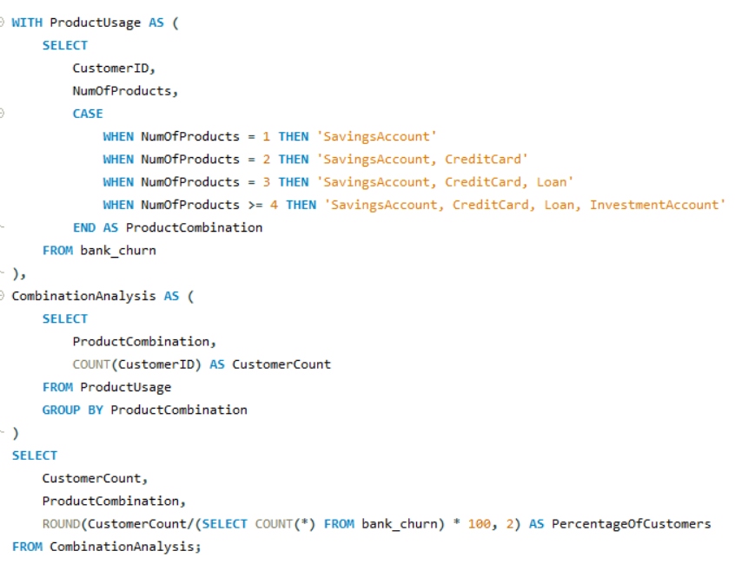
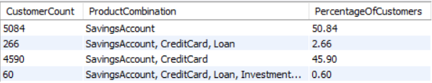

Insights:
- High Adoption of Savings + Credit Card Combination
A substantial 45.90% of customers hold both a savings account and a credit card. This indicates strong engagement with foundational banking products and presents a clear runway for promoting additional services (e.g., loans, investments, insurance).
- Low Adoption of Full-Service Product Bundles
Only 0.60% of customers utilise the complete suite of products (savings, credit cards, loans, and investment accounts). This shows a significant gap in multi-product penetration and highlights an opportunity to strengthen the bank's value proposition through integrated offerings.
- Minimal Loan Penetration
With just 2.66% of customers holding a loan product as part of their mix, loan adoption is notably low. This could imply:
  - Insufficient promotion
  - Complex approval processes
  - A mismatch between customer needs and available loan products
Recommendations :
- Drive Cross-Sell to Savings-Only Customers
Customers with only a savings account represent a large, under-utilised segment. Targeted outreach—via personalised communication, behavioural triggers, or lifecycle-based nudges—can help cross-sell credit cards, loans, and investments.
- Introduce Value-Driven Bundled Offerings
Consider launching “Integrated Financial Bundles” (e.g., savings + credit card + personal loan) with preferential interest rates or exclusive benefits. Bundles not only increase product penetration but also strengthen stickiness and reduce churn.
- Expand Investment Product Adoption
Identify customers demonstrating higher balances, stable incomes, or risk-aware behaviours, and offer personalised investment products (e.g., mutual funds, recurring investments, or wealth management services).
- Segment-Specific Engagement Playbooks
Leverage cross-product usage data to craft personalised engagement strategies. For example:
  - Savings + Credit Card users: Push loan eligibility and investment opportunities.
  - Loan-holders: Promote credit protection, insurance, or wealth-building products.
  - Savings-only customers: Prioritise financial literacy and onboarding nudges.

Q3. Geographic Market Trends: How do economic indicators in different geographic regions correlate with the number of active accounts and customer churn rates?

Sol:
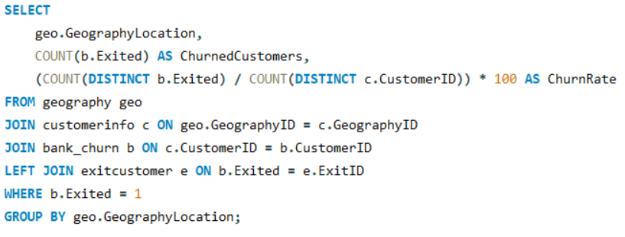

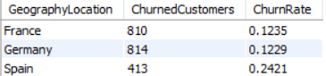

Insights:
- France and Germany exhibit nearly identical churn rates—0.1235 and 0.1229 respectively—indicating that customer attrition in these two geographies is largely consistent.
- Spain stands out with a churn rate of 0.2421, which is almost double that of France and Germany. This signals a significantly higher propensity for customers in Spain to exit banking services.
- Germany records the highest count of churned customers (814), closely followed by France (810). Spain shows the lowest churn count (413), implying a smaller customer base despite its elevated churn rate.
- The stark variation in churn rates—particularly Spain’s disproportionate churn—suggests geography-specific differences in customer satisfaction, market dynamics, or service experience.

Recommendations :
- Prioritize Spain with focused churn-reduction initiatives. Conduct deep-dive diagnostics to uncover root causes—service dissatisfaction, competitive pressure, product relevance, or economic conditions—and deploy corrective measures such as improved service quality, tailored product offerings, or proactive customer engagement.
- Even though France and Germany maintain comparatively lower churn rates, reinforcing loyalty through personalized experiences, rewards programs, and proactive retention strategies can help protect this stability and drive incremental improvement.
- Undertake market research specifically for Spain to validate hypotheses around customer dissatisfaction and competitive landscape, enabling data-backed intervention strategies.
- Given the more stable churn environment in France and Germany, the bank can strategically invest in customer acquisition in these regions to grow the active customer base while leveraging the lower attrition risk.

Q4. Risk Management Assessment: Based on customer profiles, which demographic segments appear to pose the highest financial risk to the bank, and why?

Sol: 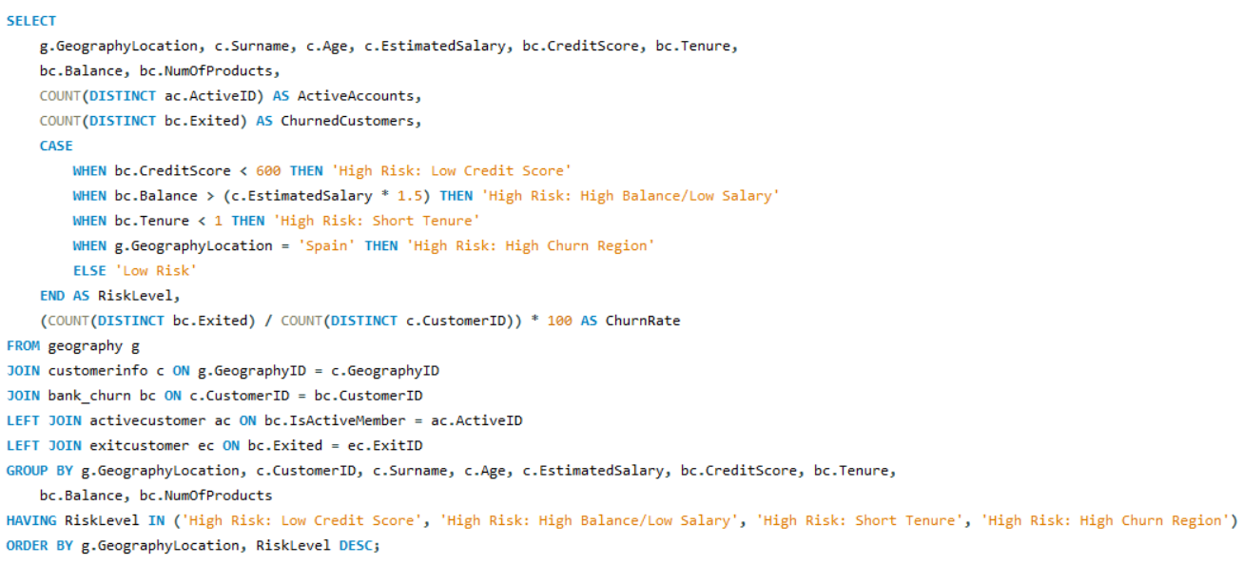

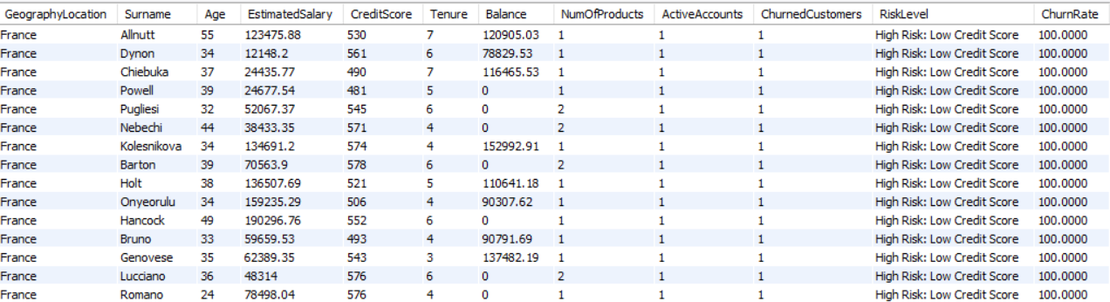

Insights:
- Customers with credit scores below 600 exhibit a significantly higher likelihood of churn, indicating that financially vulnerable individuals are more prone to disengagement. This may be driven by repayment challenges or a perceived lack of institutional support.
- Customers holding balances greater than 1.5× their estimated salary often signal underutilized funds or possible financial stress. Such imbalance can reduce their engagement with banking products and may contribute to dissatisfaction or eventual churn.
- Tenure under one year is strongly correlated with higher churn, highlighting gaps in the onboarding journey. This reinforces that the initial months are crucial for establishing customer trust, value perception, and product adoption.
- Spain continues to demonstrate the highest churn rate among regions, implying localized frictions—such as stronger competition, cultural or language nuances, or region-specific service gaps.
Recommendations :
- Deploy predictive segmentation models using credit score, balance-to-salary ratio, tenure, and geography to proactively identify high-risk customers. Engage them through financial advisory support, personalized offers, and tailored retention campaigns.
- Strengthen the onboarding framework by implementing personalized welcome journeys, proactive check-ins, and early product education to reduce first-year attrition.
- Conduct regional churn diagnostics in Spain to identify the root causes of dissatisfaction. Leverage these insights to deliver region-specific enhancements such as localized customer service, targeted marketing interventions, or competitive product bundles.
- Set up real-time monitoring of financial risk indicators—such as unusually high balance-to-salary ratios—to trigger early alerts for the retention team and enable timely intervention before customers disengage.
Q5. Customer Tenure Value Forecast: How would you use the available data to model and predict the lifetime (tenure) value in the bank of different customer segments?

Sol:
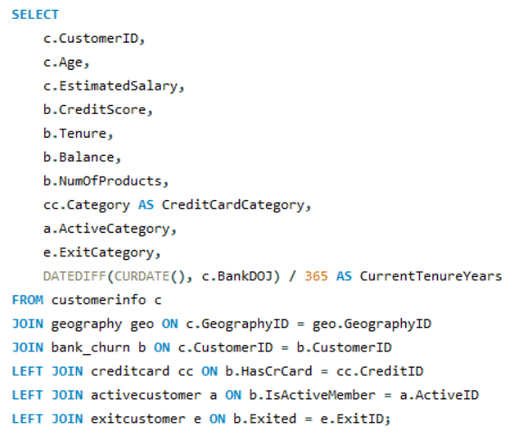
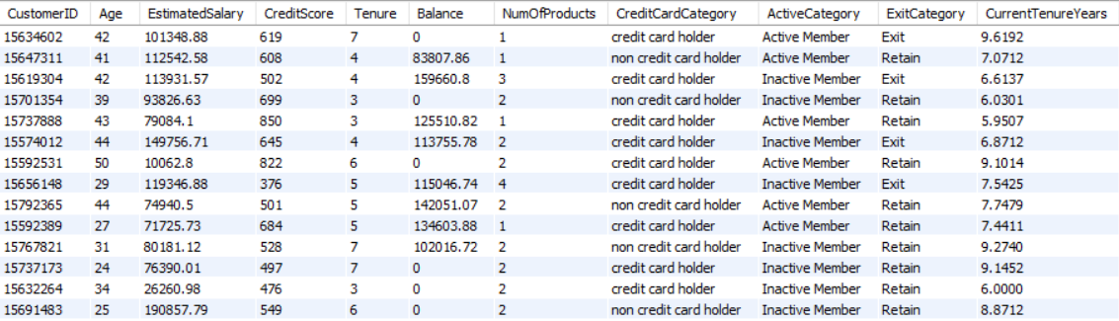

Insights:
- Customers with higher account balances tend to demonstrate longer tenure, indicating a strong correlation between financial engagement and loyalty to the bank.
- Inactive customers consistently show shorter tenure compared to active customers, signalling early disengagement and weaker long-term relationship value.
- Customers holding multiple products—particularly those with credit cards—exhibit significantly longer tenure, reinforcing that cross-selling directly contributes to improved retention.
- Retained customers consistently maintain higher tenures, while exited customers show notably shorter tenures, underscoring tenure as a key indicator of churn risk.
Recommendations :
- Strengthen retention among active customers by offering personalized financial solutions, targeted benefits, and proactive relationship management to further extend their tenure.
- Re-engage inactive customers using tailored reactivation campaigns, exclusive offers, and periodic nudges to restore their engagement and prolong their lifecycle.
- Accelerate cross-selling initiatives, focusing particularly on customers who do not own credit cards, to increase tenure duration and overall customer lifetime value.
- Leverage predictive analytics to detect early churn signals, enabling the bank to deploy timely interventions and structured incentives to prevent customer exit.
Q6. Marketing Campaign Effectiveness: How could you assess the impact of marketing campaigns on customer retention and acquisition within the dataset? What extra information would you need to solve this?

Sol: To effectively evaluate the influence of marketing campaigns on both customer retention and acquisition within the dataset:

Incorporate campaign participation data by adding details such as campaign type, launch date, and incentives offered. This can be managed through a dedicated Campaign table linked to CustomerInfo, ensuring a structured view of campaign-to-customer mapping.

Compare pre- and post-campaign retention and acquisition metrics to assess behavioural changes. Key indicators such as Tenure, Balance, and NumOfProducts can help determine whether customers increased their engagement following campaign exposure.

Analyse the rise in new customer acquisitions, tracking CustomerID counts after campaign deployment across different geographies and demographic groups to identify which segments responded most positively.

Evaluate retention outcomes by measuring how many customers remained active (ExitID = 0) after the campaign versus those who exited. A higher proportion of active customers post-campaign would indicate improved campaign effectiveness.

Additional Data Requirements : To conduct a robust and comprehensive analysis, the following information is essential:
- Detailed campaign attributes including campaign name, start/end dates, target segment, and incentive structure.
- Customer engagement data outlining interactions with specific marketing efforts (e.g., discounts, promotional offers, product activations).
- Timestamped customer activity, enabling clear before-and-after comparisons to identify behavioural shifts resulting from campaign exposure.
Q7. Customer Exit Reasons Exploration: Can you identify common characteristics or trends among customers who have exited that could explain their reasons for leaving?

Sol:
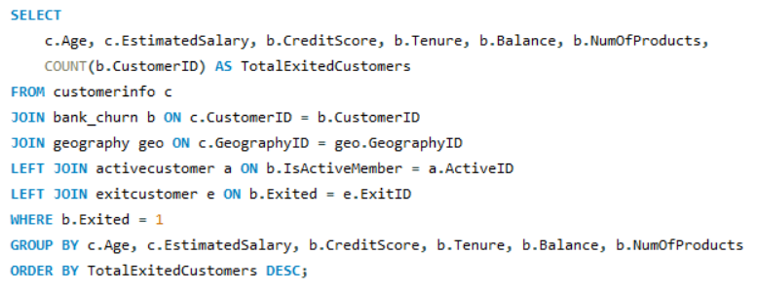
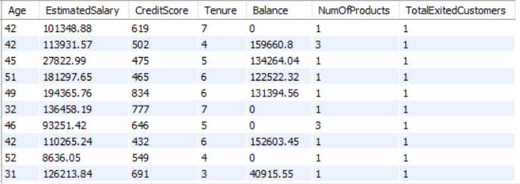

Insights:
- A substantial portion of exited customers exhibit low engagement, typically holding only one or two products, indicating a limited relationship depth with the bank.
- A notable segment of churned customers also falls within the low credit score bracket (below 500), suggesting heightened financial vulnerability and potential repayment challenges.
- Interestingly, several customers exited despite maintaining high account balances, highlighting that dissatisfaction may stem from service quality or experience rather than financial constraints.
- Additionally, customers with longer tenures (4–7 years) are also found among the churned population, implying that attrition can occur even after extended relationships and is not limited to newer customers.
Recommendations :
- A substantial portion of exited customers exhibit low engagement, typically holding only one or two products, indicating a limited relationship depth with the bank.
- A notable segment of churned customers also falls within the low credit score bracket (below 500), suggesting heightened financial vulnerability and potential repayment challenges.
- Interestingly, several customers exited despite maintaining high account balances, highlighting that dissatisfaction may stem from service quality or experience rather than financial constraints.
- Additionally, customers with longer tenures (4–7 years) are also found among the churned population, implying that attrition can occur even after extended relationships and is not limited to newer customers.
Q8. Are 'Tenure', 'NumOfProducts', 'IsActiveMember', and 'EstimatedSalary' important for predicting if a customer will leave the bank?

Sol: Yes. All four variables play a meaningful role in determining whether a customer is likely to exit the bank. Each contributes unique behavioural signals that strengthen churn prediction models.

Tenure Customers with shorter tenure tend to have weaker relationships with the bank and are therefore more susceptible to churn.
While long-tenure customers are generally more loyal, they may still exit if long-term dissatisfaction builds—making tenure a valuable behavioural indicator.

Number of Products Customers holding fewer products are less embedded in the bank’s ecosystem and can switch more easily.
Conversely, customers with multiple products are more engaged and typically harder to lose. This makes NumOfProducts a strong driver of retention and churn likelihood.

IsActiveMember Customer activity level is directly tied to engagement.
Inactive customers show weak interaction with banking services and often represent a high-risk churn segment. This variable is one of the most critical behavioural predictors.

EstimatedSalary Income levels influence product adoption and financial behaviour.
Higher-salary customers may receive premium experiences, reducing churn risk, while lower-income customers might be more sensitive to financial stress or competitive offers.

Why These Variables Matter :

Together with other features like CreditScore, Balance, Geography, and Age, these variables help form a holistic customer profile.
They are commonly used in machine learning models such as Logistic Regression, Random Forest, XGBoost, and Neural Networks to accurately classify churn risk.
Q9. Utilize SQL queries to segment customers based on demographics and account details.

Sol:
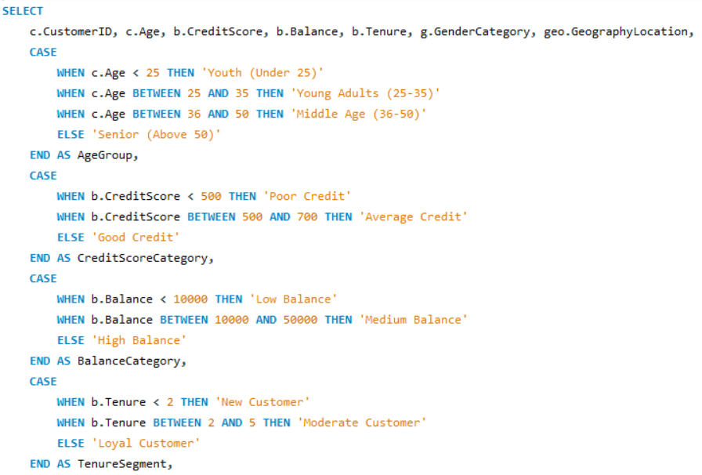
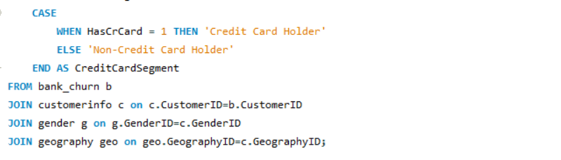

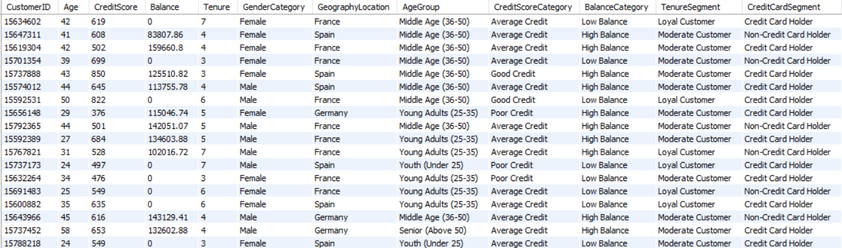

Insights:
- A large portion of Young Adults (25–35) and Middle Age (36–50) customers demonstrate high credit scores (700+) coupled with high account balances, signalling strong financial health and long-term value potential.
- Customers positioned in the “Good Credit” and “Loyal Customer” tenure segments are more likely to hold credit cards and maintain higher balances, indicating strong engagement and deeper product penetration.
- Customers with “Poor Credit” consistently show lower balances, especially within the Middle Age (36–50) age segment, suggesting financial stress or reduced banking activity.
Recommendations :
- Strengthen retention strategies for Loyal High-Credit customers by introducing premium offerings, exclusive rewards, and long-term engagement programs to reinforce loyalty.
- Design targeted financial solutions for Poor Credit customers—such as credit rehabilitation plans, personalised advisory sessions, or flexible loan products—to improve financial stability and minimise churn.
- Promote cross-selling to Moderate Customers, especially those with Average Credit, by offering bundled products or tailored financial packages to drive higher engagement, longer tenure, and increased product adoption.
Q10. How can we create a conditional formatting setup to visually highlight customers at risk of churn and to evaluate the impact of credit card rewards on customer retention?

Sol:

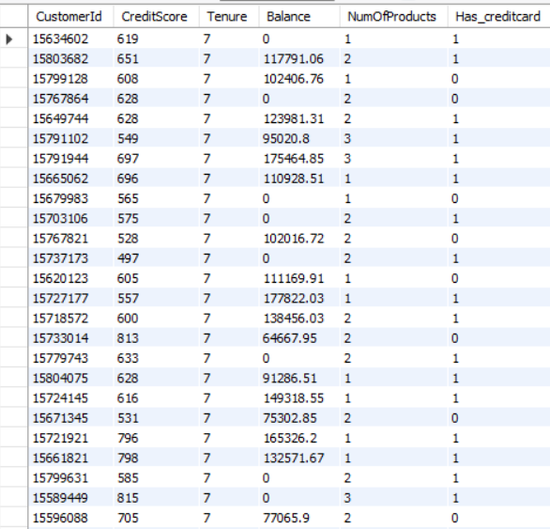

Insights:
- Customers with credit scores below 500 and balances under 30,000 fall into a high-risk churn segment, indicating that financial vulnerability is a key churn driver. Although customers with a tenure of 3+ years generally demonstrate higher loyalty, those with weak credit profiles or low product participation remain exceptions and require focused intervention.
- The mere possession of a credit card does not inherently reduce churn; however, its effectiveness appears to depend on reward structures and card tiers. Customers holding premium cards and maintaining higher balances show significantly stronger retention.
- Additionally, customers with balances between 30,000 and 80,000 who actively use reward features demonstrate improved retention, suggesting that well-structured reward programs have a notable impact on medium-balance customer behaviour.
Recommendations :

- Develop targeted retention initiatives for customers with credit scores below 500, including personalized credit-building programs and tailored financial products to improve their engagement trajectory.
- Refine and diversify credit card reward offerings, especially for customers in the 30,001–80,000 balance range, ensuring the rewards are aligned with spending behaviour and preferred categories.
- Enhance early-tenure customer engagement (less than 3 years) through improved onboarding experiences, curated product bundles, and incentives to deepen financial participation.
- Continuously monitor geographic trends and balance-related behaviour to fine-tune region-specific loyalty strategies, ensuring product relevance and optimizing customer lifetime value.
Q11. What is the current churn rate per year and overall as well in the bank? Can you suggest some insights to the bank about which kind of customers are more likely to churn and what different strategies can be used to decrease the churn rate?

Sol:
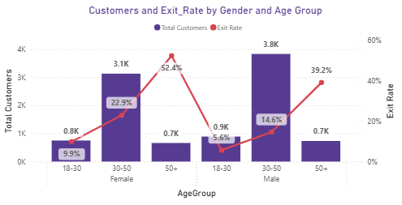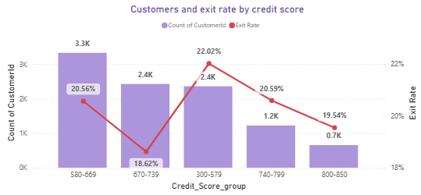
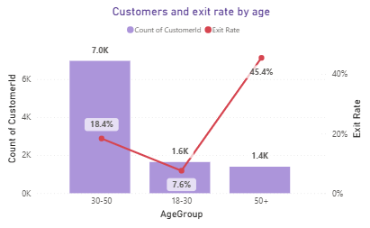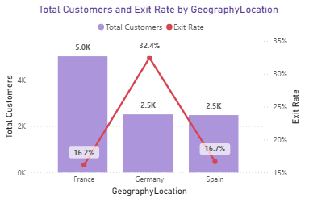

Customer Segments Most Likely to Churn
Using the visual insights from your charts, several high-risk customer profiles clearly stand out:

1. Geographic Risk: Germany Customers
- Germany has the highest churn rate at ~32.4%, nearly double the churn rate of France and Spain.
- Indicates strong regional dissatisfaction—possibly due to competition, lack of localized products, or service gaps.
What it means:
Germany requires targeted retention strategies and deeper root-cause analysis.

2. Age Group: Older Customers (50+)
- Exit rate for customers above 50 years is ~39–45%, the highest across all age brackets.
- These customers might feel underserved, digitally challenged, or not receiving relevant financial products.
What it means:
High-touch advisory and tailored retirement-oriented offerings are essential.

3. Gender + Age Combination: Females aged 30–50
- This segment has an exceptionally high churn of ~52.4%.
- Despite being a large customer base (~3.1K), retention is weak.
What it means:
This demographic may need personalized engagement or product alignment with their financial goals (insurance, investments, loans).

4. Credit Score Segments
- Customers with credit scores 580–669 and 300–579 show churn rates of 20.56% and 22.02% respectively.
- High-risk credit segments tend to churn more, likely due to:
  - loan rejections
  - poor offers
  - dissatisfaction due to higher interest rates
What it means:
Financial wellness programs and credit-improvement strategies can reduce churn.

Key Strategic Recommendations
Here’s a pragmatic, corporate-grade set of strategies the bank can immediately deploy:

1. Region-Focused Retention Strategy (Germany First)
- Launch location-specific offers tailored to German clients.
- Improve customer support responsiveness and branch-level experience.
- Analyze competitor movements in this geography.

2. Strengthen Engagement for 50+ Customers
- Design investment and retirement-friendly financial products.
- Offer relationship managers dedicated to senior clients.
- Simplify digital touchpoints (mobile app, banking portal).

3. Targeted Retention Programs for Low Credit Score Customers
- Introduce credit-building programs.
- Provide lower-risk loan alternatives or secured products.
- Use proactive communication to prevent dissatisfaction at rejection points.

4. Address High Churn in Female 30–50 Demographic
- Provide customized family-oriented products (health, education funds, high-yield savings).
- Create marketing campaigns specifically targeting this customer group.
- Introduce loyalty plans tied to spending, savings, or investments.

5. Improve Onboarding for Young Customers (18–30)
- Their churn is lower, but they represent future high-value customers.
- Offer:
  - starter credit cards
  - low-cost investment plans
  - student or early-career financial bundles

6. Cross-Sell and Up-Sell to Medium-Balance Customers (30K–80K)
- These customers show moderate churn but strong responsiveness to reward programs.
- Enhance credit card rewards, cashback categories, and loyalty tiers.
Q12. Create a dashboard incorporating all the KPIs and visualization-related metrics. Use a slicer in order to assist in selection in the dashboard.

Sol:
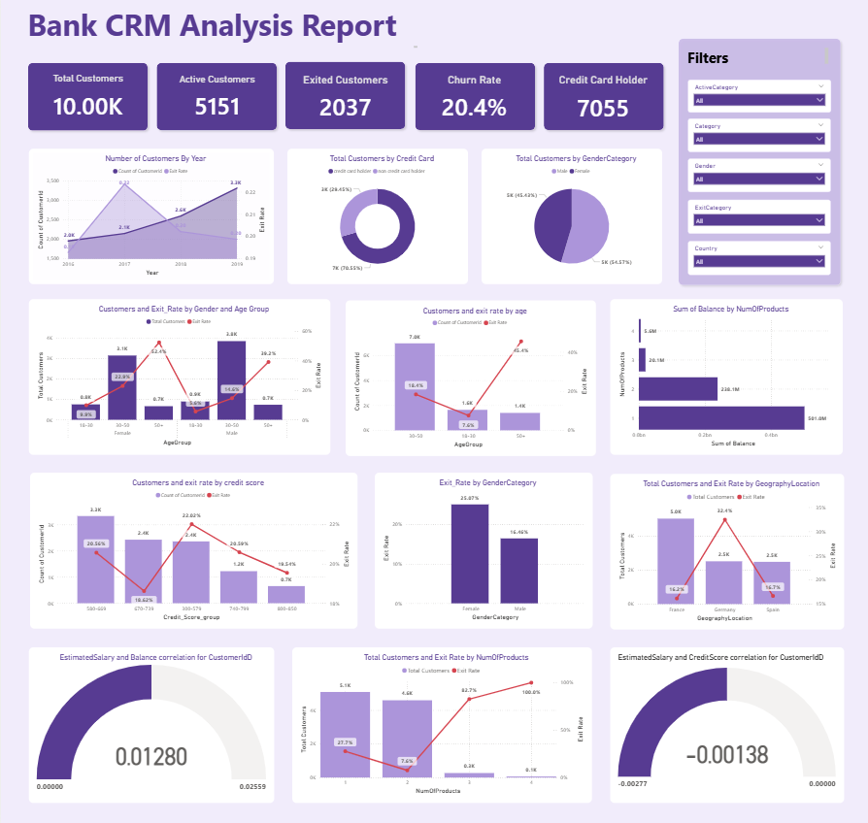

Q13. How would you approach this problem, if the objective and subjective questions weren't given?

Sol: If the objective and subjective questions were not provided, I would approach the analysis of the Bank_Churn dataset through a structured, insight-driven workflow:

1. Understand the Data Landscape

I would begin by reviewing the dataset schema and the ER diagram to map out table relationships and data dependencies. Key tables such as customerinfo, bank_churn, exitcustomer, and activecustomer would be assessed to understand demographic attributes, account behaviours, and churn indicators.

2. Data Quality & Preprocessing

Next, I would conduct a thorough data-quality audit:

Missing Values: Identify nulls or inconsistencies in critical columns such as CreditScore, Balance, EstimatedSalary, and NumOfProducts.

Logical Conflicts: Validate fields like IsActiveMember vs. Exited to eliminate contradictions.

Data Transformation: Standardize formats, rename ambiguous fields (e.g., HasCrCard → Has_CreditCard), and create engineered features where needed.

3. Define Key Business Metrics

Without predefined questions, I would derive core metrics that typically drive customer behaviour analytics:

Overall Churn Rate and churn segmented by age, geography, gender, and tenure.

Product Penetration and usage patterns across different customer cohorts.

Credit Score Behaviour across retained vs. exited customers.

Lifetime Value Indicators based on tenure and engagement.

4. Customer Segmentation

I would build meaningful segments using demographic and behavioural attributes such as age groups, geography, credit score clusters, balance tiers, and product usage. This helps identify the profiles most associated with churn or high value.

5. Insight Generation Through SQL

Using SQL, I would derive actionable trends:

Churn Diagnostics: Churn by year, region, gender, and customer profile.

Product Affinity: Identify common product bundles to uncover cross-sell opportunities.

Credit Score Trends: Explore correlations between credit score levels and churn.

Retention Insights: Analyse retention based on engagement and product depth.

6. Analytics & Visualization

I would translate the insights into decision-ready dashboards:

Churn audits

Customer segmentation

Product utilisation

Credit score distributions

Time-series trends

With visual cues such as conditional formatting to highlight high-risk customers.

7. Strategic Business Recommendations

Finally, I would translate the analytical output into business actions:

Retention Playbooks: Personalised interventions, loyalty initiatives, and targeted engagement for at-risk customers.

Cross-Sell and Upsell Strategies: Based on product affinity and segment behaviour.

Credit Score Improvement Programs: Advisory and financial coaching for low-scoring segments.
By using these methods, we can effectively identify and handle outliers to ensure accurate data analysis.
Q14. In the “Bank_Churn” table how can you modify the name of the “HasCrCard” column to “Has_creditcard”?

Sol:
